Name : Khush Pithva 24BCE174
Subject : Data Structure (2CS501)
Practical no.: 7A
AIM : Create a simple graph to manage the relationships between different departments in your
university. Each department can communicate directly with other departments.
Departments and their direct communication links:
● Department A communicates with Department B and Department C.
● Department B communicates with Department C and Department D.
● Department C communicates with Department D.
● Department D communicates with Department E.
● Department E communicates with Department A.

Represent the departments as nodes and the communication links as edges. Create an adjacency
matrix for the graph. Indicate if the graph is directed or undirected.
INPUT :
#include <bits/stdc++.h>
using namespace std;

void printMatrix(int n, int mat[][100])
{
cout << "Adjacency Matrix:\n";
for (int i = 1; i <= n; i++)
{
for (int j = 1; j <= n; j++)
{
cout << mat[i][j] << " ";
}
cout << endl;
}
}

void dfs(int node, int n, int mat[][100], int vis[])
{
vis[node] = 1;
cout << node << " ";

for (int i = 1; i <= n; i++)
{
if (mat[node][i] == 1 && !vis[i])
{
dfs(i, n, mat, vis);
}
}
}

void bfs(int start, int n, int mat[][100], int vis[])
{
queue<int> q;
q.push(start);
vis[start] = 1;

cout << "\nBFS Traversal starting from node " << start << ":\n";
while (!q.empty())
{
int node = q.front();
q.pop();
cout << node << " ";

for (int i = 1; i <= n; i++)
{
if (mat[node][i] == 1 && !vis[i])
{
q.push(i);
vis[i] = 1;
}
}
}
cout << endl;
}

int main()
{
int n, m;
cout << "Enter number of vertices and edges: ";
cin >> n >> m;

int mat[100][100] = {0};

cout << "Enter each edge (u v):\n";
for (int i = 0; i < m; i++)
{
int u, v;
cin >> u >> v;
mat[u][v] = 1;
}

printMatrix(n, mat);

int vis[100] = {0};

cout << "\nDFS Traversal starting from node 1:\n";
dfs(1, n, mat, vis);

fill(vis, vis + n + 1, 0);

bfs(1, n, mat, vis);

return 0;
}

Output :
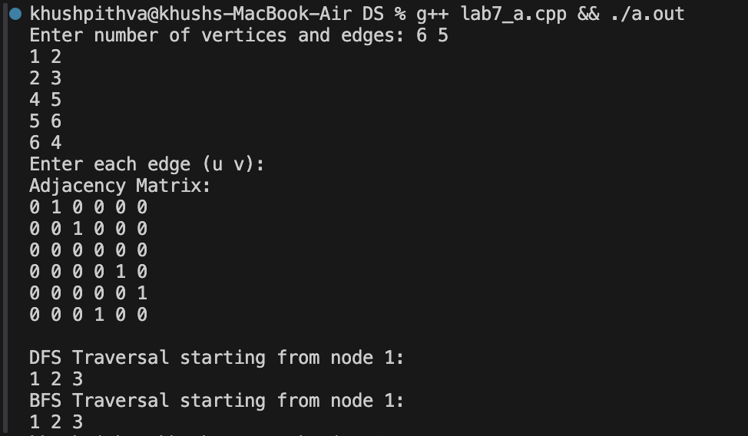
Practical No: 7(b)
Aim: Using the above graph, perform following:
● Create an adjacency matrix for the graph.
● Perform a Depth-First Search (DFS) starting from Department A.
● Perform a Breadth-First Search (BFS) starting from Department A.
● Find the shortest path from Department A to Department D using BFS.
Input:
#include<bits/stdc++.h>
using namespace std;

void dfs(int start, vector<bool>& visited, vector<vector<int>>& adj) {
stack<int> st;
st.push(start);
while (!st.empty()) {
int v = st.top();
st.pop();
if (!visited[v]) {
visited[v] = true;
cout << v << " ";
}
for (int i = adj[v].size() - 1; i >= 0; i--) {
if (adj[v][i] == 1 && !visited[i]) {
st.push(i);
}
}
}
}

void bfs(int start,vector<bool>& visited,vector<vector<int>>& adj){
queue<int> q;
visited[start]=true;
q.push(start);
while(!q.empty()){
int v=q.front();
q.pop();
cout<<v<<" ";
for(int i=0;i<adj[v].size();i++){
if(adj[v][i]==1 && !visited[i]){
visited[i]=true;
q.push(i);
}
}
}
}
int main(){
vector<vector<int>> adj(5,vector<int>(5,0));
// vector<char> adj={'A','B','C','D','E'};
int n=adj.size();
vector<pair<int,int>> p={{0,1},{0,2},{1,3},{3,4},{3,2},{0,4}};
int u,v;
for(int i=0;i<p.size();i++){
u=p[i].first;
v=p[i].second;
adj[u][v]=1;
}
for(int i=0;i<n;i++){
for(int j=0;j<n;j++){
cout<<adj[i][j]<<" ";
}
cout<<endl;
}

vector<bool> visited(n,false);
cout<<"DFS Traversal: "<<endl;
dfs(0,visited,adj);
cout<<endl<<"BFS Traversal: "<<endl;
visited.assign(n,false);
bfs(0,visited,adj);
cout<<endl;
return 0;
}
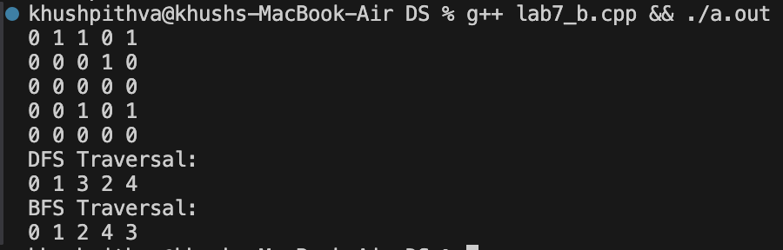

1.
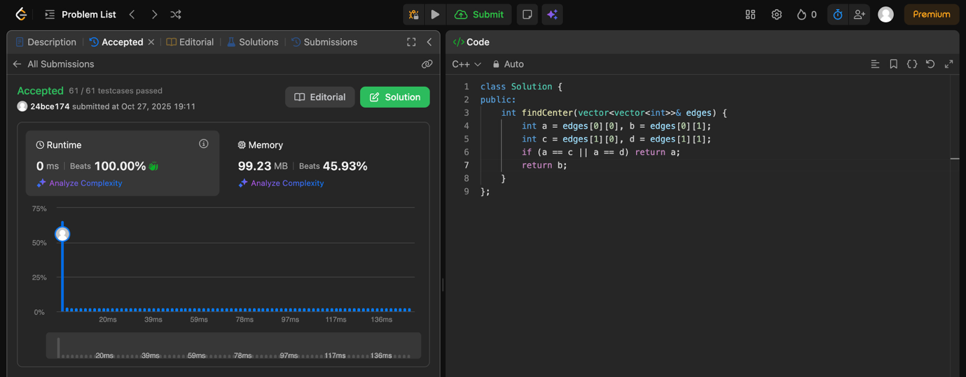

2.
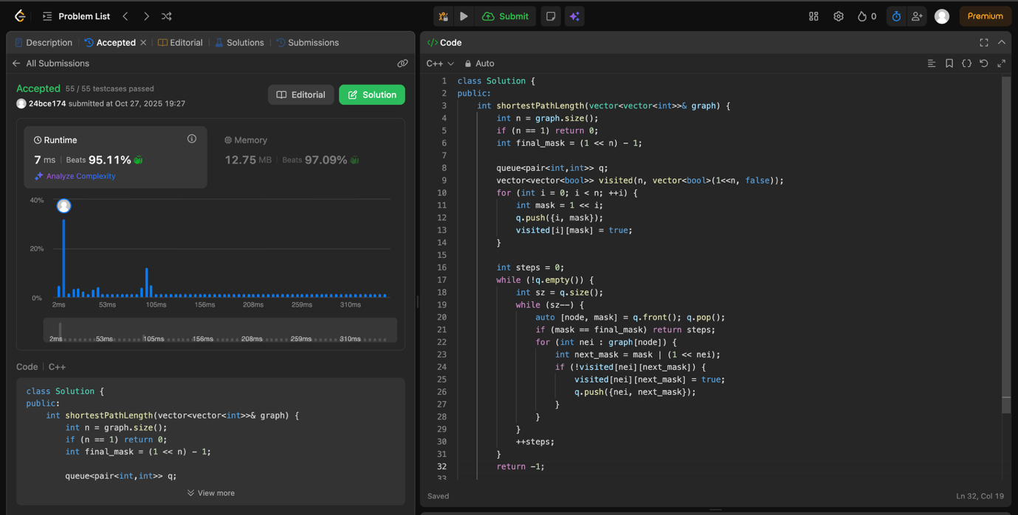

3.
